Touch-Based Automation
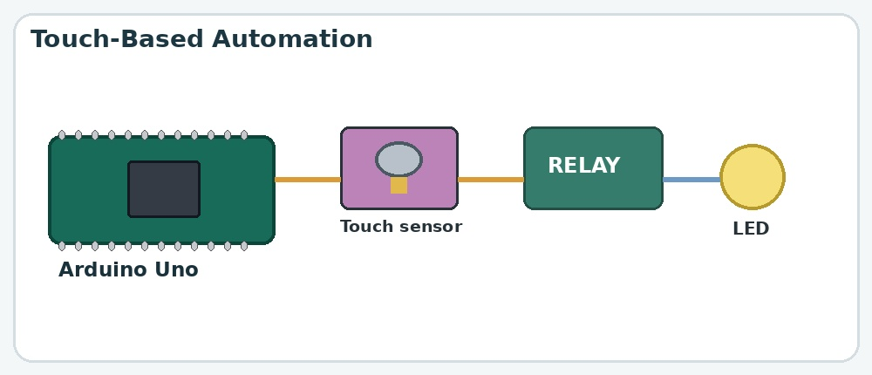

Aim
To control an electrical output, such as an LED, using a touch sensor.

What is the project?
A touch-based automation system that uses a capacitive sensor as an input and a relay as an electrically controlled switch.

How does it work?
- The capacitive touch sensor detects a touch and sends a digital signal to the Arduino Uno.
- The Arduino processes the signal according to its program.
- The Arduino activates or deactivates the relay.
- The relay switches the connected output circuit, such as an LED.
- Depending on the code, touching may turn the output on, off, or toggle its state.

Components used
- Arduino Uno
- Capacitive touch sensor
- Relay module
- 2 LEDs

Connections
Component / Pin | Typical connection
Touch sensor VCC | Arduino 5V
Touch sensor GND | Arduino GND
Touch sensor OUT 1  Touch sensor OUT 2  Touch sensor OUT 3  Touch sensor OUT 4  Relay GND  Relay VCC | Pin 2 (UNO)  Pin 3 (UNO)  Pin 4 (UNO)  Pin 5 (UNO)  Arduino GND  Arduino 3.3V
Relay IN | Pin 8 (UNO)
LED (1)  LED (2) | Pin 9 (UNO)  Pin 10 (UNO)

